HUSKYlens NITRObot stand 3D printing instructions

To 3D print the HUSKYlens NITRObot stand:

Use PLA 1.75mm filament

Use default 3D printer setings.

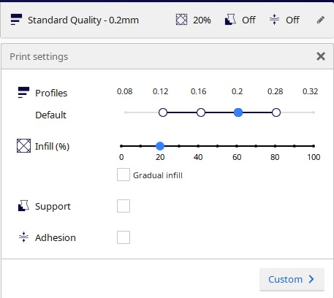

Layer thickness: 0.2 мм.

Fill: 20%.

No supports.